*Uncontrolled copy not subject to amendment*

**AIR CADET PUBLICATION (ACP) 1**

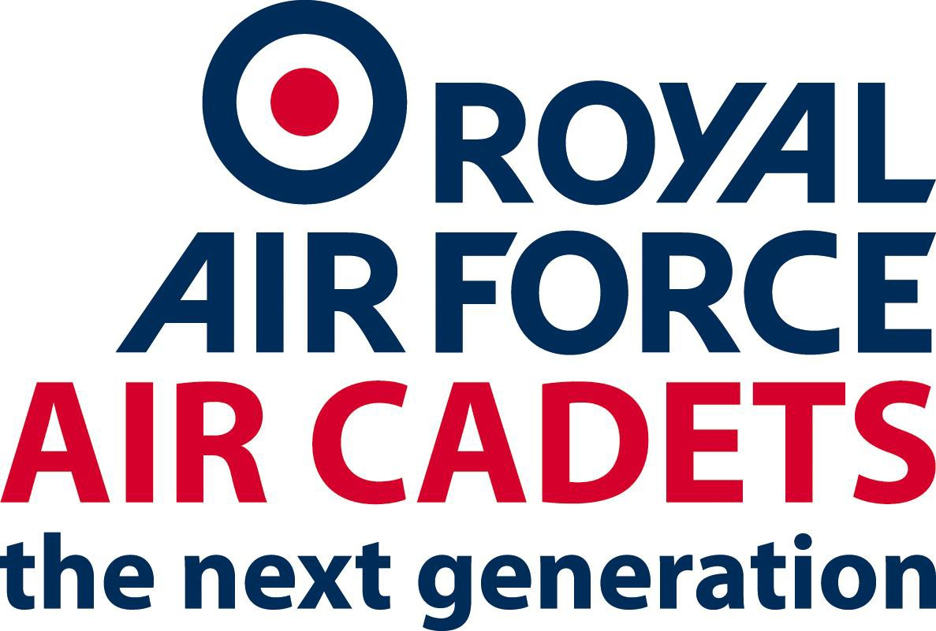

**ETHOS, CORE VALUES**

**AND STANDARDS IN THE AIR CADET ORGANISATION**

SO2 Personnel August 2012

|  |  |  |  |
| --- | --- | --- | --- |
| Date | Amendment | Amended By | Version No |
|  |  |  |  |
|  |  |  |  |
|  |  |  |  |
|  |  |  |  |
|  |  |  |  |
|  |  |  |  |
|  |  |  |  |
|  |  |  |  |
|  |  |  |  |
|  |  |  |  |
|  |  |  |  |

**ETHOS, CORE VALUES AND STANDARDS IN THE AIR CADET ORGANISATION**

**FOREWORD –** by the Commandant Air Cadets

1. As Commandant, I have the honour and responsibility of leading the Air Cadet Organisation (RAFAC) which provides challenging activities to enable it to attract and retain membership and thereby provide examples of good behaviour and leadership for today’s youth. The RAFAC’s mission is to be the modern, dynamic, sustainable air minded youth organisation of choice that offers fun and challenging opportunities for both cadets and volunteers. As the uniformed youth service parented by the Royal Air Force, the RAFAC has the following aims: to promote and encourage among young people a practical interest in aviation and the RAF; to provide training which will be useful both in Service and civilian life; and, to foster the spirit of adventure, and to develop the qualities of citizenship and leadership. The RAFAC has a proud tradition and a reputation for excellence. To maintain and enhance that reputation we must respect and properly recognise the value of all the men, women and cadets who serve in, or who support, the RAFAC.

2. This booklet sets out the Ethos, Core Values and Standards which we must all uphold as members of the RAFAC. These values and standards are not only the foundation of mutual trust and respect within the RAFAC but they are also central to our ability to work together with other uniformed youth services, the regular Services and with everyone else who supports us in our endeavours. Please read this booklet carefully. If in doubt, always remember that your values and behaviour reflect not only your own personal approach to life, but also how our organisation is seen by others.

**THE ETHOS, CORE VALUES AND STANDARDS OF THE AIR TRAINING CORPS**

**THE ETHOS OF THE AIR CADET ORGANISATION (**RAFAC**)**

1. “The Ethos of the RAFAC is made up of the distinctive character, spirit and attitudes which together inspire young people to pursue the spirit of adventure”.

2. The RAFAC needs individuals who will respond to a demanding challenge, who aspire to the required standards of excellence, who share a sense of commitment and who understand our core values. We want men and women who are proud to develop the youth of the country and whose personal qualities reflect the values required by the RAFAC. The success of the RAFAC in any endeavour is dependent upon the willingness of its volunteers to wholeheartedly support its aims. This commitment grows from a desire to help challenge young people in order to mould the ambitions of the next generation.

**Commitment and Conduct**

3. The success and good name of the RAFAC depends very heavily upon

the commitment and conduct of each and every adult volunteer. There are 2 key aspects: the correct approach to the discharge of all responsibilities, and

the highest level of personal conduct both on and off duty. W hen fulfilling

their responsibilities, all volunteers – RAFVR(T) officers, Warrant Officers

(W O (ATC)), Senior Non-Commissioned Officers (SNCO (ATC)), Civilian Instructors (CI), and Civilian Committee Members – should adhere to and set the highest standards. They should meet their obligations as volunteers by ensuring that all RAFAC training and activities are efficiently, safely and imaginatively delivered. All of the training provided by the RAFAC is designed to challenge cadets and, as appropriate, to develop their natural instinct for adventure within the safest possible environment. It is therefore vital that all volunteers exercise, with vigilance, their legal Duty of Care responsibilities for the cadets in their charge (see [ACP 4](https://sharepoint.bader.mod.uk/QM/Controlled%20Documents/ACP%20004.docx?Web=1) – Safeguarding and Protecting Children

– for further details).

4. A broad variety of personal conduct and behaviour may be regarded as acceptable in society at large. However, adult volunteer service brings with t an obligation, both on and off duty, to demonstrate the highest standards of social and moral conduct. Officers and WOs/SNCOs (ATC) frequently wear

uniform in public and, as members of their local communities, even when not in uniform, are usually known to be commissioned or hold WO(ATC) or SNCO(ATC) rank. Their social and moral conduct is therefore judged by the public in the context of their uniformed roles. Uniformed volunteers also

have more frequent and widespread contact with the public than do Regular

Armed Forces personnel and they must always be aware that they play a

very significant role in determining how society judges the Royal Air Force as a whole.

5. No-one is immune from the pressures and temptation which arise in everyday human relationships but any misconduct, whether in sexual matters or in general social behaviour, is totally inappropriate for those who wish to make a positive contribution to the development of the Nation’s youth. Misconduct, including inappropriate behaviour on the part of an adult volunteer is unacceptable, particularly if occurring between adult staff and cadets of any age, and would be regarded as extremely serious. If such misconduct suggests that a volunteer is unable to fulfil his or her obligations to the cadets in their charge, they will have to leave the RAFAC. Adult volunteers are required to conduct themselves with integrity and should find themselves in an actual or potential situation that could cause

embarrassment to others or to the RAFAC, they must report the fact immediately.

6. Wing, Squadron and Unit Commanders have the added responsibility of supervising their adult volunteers and making them aware of any failings that need to be corrected. Where their advice is ignored or serious misconduct or indiscipline has occurred, commanders must immediately take appropriate action in accordance with RAFAC rules, Service regulations and instructions.

**Caring for Young People and the Vulnerable**

7. All Organisations involved with caring for young people should, through Principles of Good Practice, have Codes of Conduct to protect against sexual activity occurring within relationships of trust. ACP 4 outlines the Principles

of Good Practice and through its Code of Conduct amplifies who is protected

and how. It must be clearly understood that every adult supervisor in the RAFAC has a personal responsibility for the safety and welfare of cadets. This applies not only to cadets under their immediate command, but generally. The safety and welfare of cadets overrides any other consideration.

**THE CORE VALUES OF THE AIR CADET ORGANISATION There are four RAFAC Core Values:**

**Respect, Integrity, Service and Excellence. Respect.**

1. There are 2 forms of respect:

**Self-Respect**.

People with self-respect do not behave in ways that would bring discredit upon themselves, the RAFAC or the Royal Air Force. They have high standards of social conduct.

**Mutual Respect**.

Genuine respect involves viewing another person as an individual of fundamental worth regardless of their race, ethnic origin, religion, gender, sexual orientation or social background.

**Integrity**.

2. Integrity is the conviction to do what is right at all times. It is the basis for trust. It co mprises:

**Courage**.

To do what an individual believes to be right, even though it may

be unpopular and the personal cost may be high. Courage to refuse

to compromise personal values in the face of opposition, and to sustain the highest standards of decency and behaviour will earn the respect of others and will build trust.

**Honesty**.

Honesty is inherent in the RAFAC and our word must be our bond. all forms of deceit, dishonesty or breaches of trust or confidence constitute a lack integrity, and therefore call into question whether an individual can be relied upon.

**Responsibility**.

Being accountable for one’s actions and decisions, a truly responsible person acknowledges his or her duty and acts accordingly.

**Justice**.

A person of integrity practises just behaviour and treatment. Those who do similar things must get similar rewards or similar punishments. Only then will an individual earn the respect and loyalty that are essential to good leadership.

**Service**.

3. Service is a willingness, when required, to put other people before ourselves. Service incorporates the values of loyalty, commitment, pride and teamwork.

**Loyalty**.

From the moment we are appointed we are each committed to uphold and preserve the values of the RAFAC. Those who are placed in positions of authority must be loyal to their team, representing their interests, dealing with complaints thoroughly, and developing their abilities through progressive training. Team members must be loyal to their leaders and their colleagues.

**Commitment**.

Commitment works in two ways. For the individual it means making a maximum contribution whenever possible. This commitment is reflected in the award of an appointment in the RAFAC. W hen on duty it imposes limitations on individual freedom and requires a degree of self- sacrifice. For those in authority, it requires them to discharge their responsibilities and their duty of care to their teams and, more importantly, the cadets in their charge.

**Pride**.

4. Pride is a justifiable confidence in ourselves and the RAFAC based on success, attitudes to life and individual team spirit. We can compare ourselves favourably with any other uniformed youth service confident in the knowledge that we excel in providing a safe and stimulating environment for the development of our cadets.

**Teamwork**.

Teamwork is essential if we are to sustain a vibrant and effective RAFAC in an ever changing society. It is about working together with each member of our organisation and with the other uniformed youth services.

**Excellence**.

5. By striving for excellence we drive for the continuous improvement and innovation which will ensure that the RAFAC remains second to none in providing a challenging and demanding environment. Our cadets can than mature and develop into well rounded individuals protected by our Duty of Care. Key qualities include:

**Self-Discipline and Self-Control**.

The most effective discipline is self-discipline, which comes from within and is not imposed. Good discipline enables us to achieve more than we would normally expect of ourselves. We should not indulge in self- pity, discouragement or uncontrolled emotion.

**Personal Excellence**.

Every member of the RAFAC must strive to achieve and maintain the highest personal standards, thereby enhancing the competence, cohesion and reputation of the RAFAC.

**Maximising Resources**.

The resources available to the RAFAC, both human and material, are limited. W e all share an obligation to ensure that our equipment and property is put to the most efficient use. We must train, sustain and retain those who can do the best job for the RAFAC.

**Pride**.

We must be proud of our expertise and that we are second to none in delivery of the cadet experience.

**LEADERSHIP**

6. Though not a core value itself, leadership is at the heart of an effective and thriving RAFAC. Good leadership inspires, underpins and enables all our qualities, values and capabilities. It can transcend limited resources and overcome the greatest of difficulties. It is not solely the preserve of

command; every member of the RAFAC has the capacity for leadership. It is an innate quality, honed and developed by training, experience and hard work. The best leadership is leadership by example:

**Albert Einstein** – *“Setting an example is not the main means of influencing another, it is the only way”.*

**A FINAL THOUGHT**

7. The success of a modern and progressive RAFAC must continue to be founded on a binding Ethos underpinned by the Core Values of **Respect, integrity, Service and Excellence**. Teamwork, success and effective leadership flourish in an environment of mutual trust and respect. In this context, we all have a responsibility to our colleagues, be they leaders or team members, to do our best to uphold our Ethos and embrace our Core Values. Behaviour or conduct which undermines trust, creates division, or which draws into question the good name of the RAFAC, we should take pride in our traditions and we should do all we can to sustain the values which characterise RAFAC life. This is a reflection of our unique role in helping to prepare the young people of the country to take and accept their role as positive and active citizens in society at large. In doing so, they will be our most effective ambassadors.

This publication does not discriminate on grounds of race, ethnic origin, religion, sexual orientation or social background. Neither does it discriminate on grounds of gender, disability or age, insofar as the legislation applies to the RAFAC. This document is sponsored by COS RAFAC.